1. **INTRO**

While the Sunway TaihuLight which from now on will be referred to as the Sunway, once stood on top of the computing world, it has been overthrown by the infamous IBM Summit super computer. However, before the IBM Summit supercomputer came into the picture, China was leading the world in supercomputing, sitting at rank number one ranking for two years, only being overthrown in June of 2018 (Erich, Dongarra and Simon). The Sunway is located in Wuxi, China at the Nation Supercomputing Center and was developed at the same center with the support of the National High Technology research and the “863” program or the Development Program of China (The National Supercomputing Center). To this date the Chinese supercomputer ranks at third in the top500 rankings with its peak performance of 125,435.9 TFlops/s, and at its average performance which the machine was measured to run 93,014.6 TFlops/s (Erich, Dongarra and Simon).

1. **ARCHITECURE/SYSTEM OVERVIEW**

The Sunway is comprised of 10,649,600 cores, 1,310,720 GB of memory, 230 TB of SSD storage and is supported by the Chinese original Sunway SW26010 260C processors (The National Supercomputing Center). Figure one shows the general architecture of the Sunway. It is comprised of 40 cabinets, with each cabinet containing 4 super nodes, and each super node is made up of 256 nodes. One of the key components of the Sunway are the processors with each processor having the potential of having a peak performance of just over three TFlops and having a total of 260 processing elements in just one CPU (Fu). The processor architecture can be found in figure two of which it can be seen that each processor is composed of four core-groups (CG’s), with each core having its own management processing element (MPE), a computing processing element (CPE) and a memory controller (Fu). Each MPE has a 32KB L1 instruction cache, 32KB L1 data cache and a 256 KB L2 cache which gets split between both data and instructions. On the other hand, each CPE has a 16 KB L1 cache and a user-controlled scratch pad memory (SPM). The SPM is essentially a cache that the user can tweak for whatever needs that they have, making the processors more flexible with different types of computations. Furthermore, each CG is connected to a network along with a storage system. The many-core processor runs at 1.45 GHz and implements DDR3 technology to deal with its data intake. 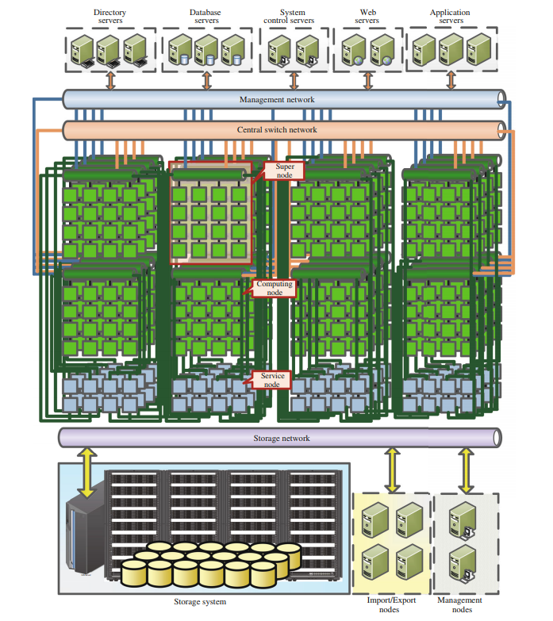

**Figure 1: Sunway TaihuLight Architecture** (Dongarra)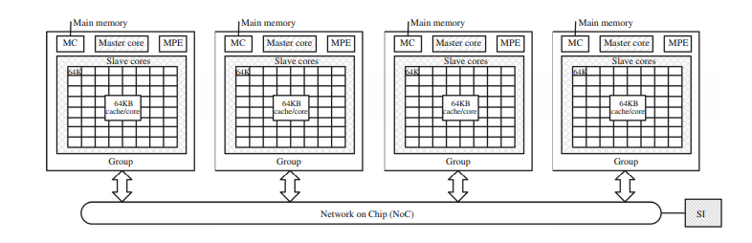

**Figure 2: Sunway Processor Architecture** (Fu)

1. **STRENGTHS**

Many of the strengths for the Sunway comes from the software that’s compatible with Supercomputer. Since the main applications of the supercomputer are research based there is an abundance of data that the computer has to deal with. Some of the major areas that the Sunway is used for are the following (Dongarra):

* Atmosphere modelling
* weather forecasting
* 3D Parallel Numerical Simulation
* Atomic simulation of silicon nanowires
* big data analytics

The Sunway has done its best to optimize it’s Sunway OpenACC 2.0 tool to allow for better data management and fast computation times. The software was optimized in a way such that the algorithms will use the data on board of the processors as much as it can as opposed to using the main data which allows for a significant increase in run times. To add to this, the algorithms that have been optimized for the Sunway make difficult, large, and complex computations like those of the atomic simulation of silicon nanowires or atmosphere modelling run smoother with more cores simultaneously working on the problem due to the help from the OpenACC 2.0 tool. Another key strength comes from the processor. Despite running at 1.45 GHz, the utilization of the multiple cores is where the Sunway really shines. Thanks to the parallelism that will be discussed later, the Sunway is able to tackle previously thought to be extremely difficult simulations with relative ease.

1. **WEAKNESSES**

Some of the weaknesses in the Sunway would include the amount of power required to machine. It takes approximately 15,371 Kw to power the Sunway and when you compare that to some of the other supercomputers like the American Summit Supercomputer which runs at 9,783 Kw or Sierra which runs at 7,438 Kw, they are able to run at nearly half the power consumption and are better than Sunway. Even looking at some of the weaker supercomputers behind the Sunway, Switzerland’s PizDaint only requires 2,348 Kw mind you that it is also about 70 TFlops slower (Erich, Dongarra and Simon). Additionally, despite having nearly 8 million more cores compared to the Summit supercomputer, the Sunway is nearly 50 TFlops weaker. Not only are there hardware flaws but there are also flaws within the software that was developed for the Sunway. Even though it was optimized from their previous software it still has some flaws with how fast the data can be read and stored by the processor. Lastly, not all of the software developed for the Sunways was completely finished. With some room for further improvement and optimization, its left additional work for the programmers to deal with.

1. **PARALLELISM**

The Sunway’s main source or parallelism comes from the way the it was designed. Sunway uses the basic C/C++ language, fortan compilers, an automatic vectorization tool, basic math libraries (Fu). Using these allows the Sunway to use its compiling tool Sunway OpenACC to allow for parallelism at the node level. The Sunway OpenACC 2.0 syntax targets the CG’s in the processor to allow for better computation. For example, one of the functions that the Sunway was optimized for was highly effective global surface wave numerical simulation with ultra-high resolution (Fu), which up until the Sunway had some difficulties computing with such vast amounts of data. However, Sunway ended up optimizing an algorithm that used features of the processor such as the MPE and CPE as well as the data that was available on the processor. Figure 3 shows an example of how the processors work simultaneously, sync up and then return an output. Initially all the data is broken up into chunks and assigned to different blocks, then the processors all grab the data they require to do computations, once done the computations they set a sync flag using the scratch pad memory that is available to each processor. The processors all wait until everything is synced up before moving on, and by using the storage on the processor they are able to move faster since they don’t have to reach to the main data. 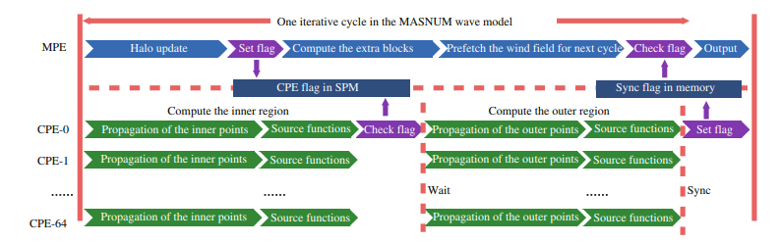

**Figure 3: Pipeline example** (Fu)

1. **COMPARATIVE ANALYSIS**

As mentioned earlier, the Sunway used to sit at the top of the charts before being overthrown by the IBM Summit supercomputer. With the summit running at a peak performance of 193,536 TFlops and the Sunway running at 125,435.9 TFlops/s the Sunway is clearly outclassed and perhaps a bit behind the times, taking significantly more power to run and using more cores to produce less. However, it should be considered that the Summit uses GPU units while the Sunway does not which might account for the difference in cores. One important feature to also consider is that both the computers were made with difference uses in mind. While the Sunway has been made for the purposes of research, its main focus has been to deal with large abundant sources of data while the Summit seems to be more interested in dealing with adaptive resources like machine learning and artificial intelligence. Lastly, the architecture of the two supercomputers.

**References**

Dongarra, Jack. *Report on the Sunway TaihuLight System*. Technical Report. University of Tennessee: Department of Electrical Engineering and Computer Science, 2016.

Erich, Strohmaier, et al. *Top500*. November 2018. 1 April 2019.

Fu, HaoHuan, et al. "The sunway TaihuLight supercomputer: system and applications." *Science China Information Sciences 59.7* (2016): 072001.

The National Supercomputing Center. *Hardware*. 2019. 1 April 2019.

—. *Introduction*. 2019. 1 April 2019.